Title: Analysis of Unprecedented Flooding in the UAE, 2024
Muhammad Areeb,
School of Geography and Development
Dr. Wim van Leeuwen,
April 29, 2024

Contents
Objective 2
Introduction 2
Methodology 2
Choosing Water Index (Analysis of Peer-reviewed References) 2
Process 5
Result and Conclusion 7
Areas for Improvement 8
References 9

Objective
The aim of this project is to examine the effects of a rather uncommon occurrence of flooding in the United Arab Emirates between 18th March and 19th April, 2024.

Introduction

The United Arab Emirates, a vibrant metropolis in the Middle East recently experienced an unprecedented and unexpected natural disaster towards the end of March and the first week of April in 2024: a torrential rain that led to widespread flooding. This type of phenomenon is usually extremely rare for an arid region such as the UAE. This led to significant damage to the desert infrastructure which is not used to this type of atrocities. Vehicles had sunk in underground parking and underpasses. The electric grids were affected in most regions of the coastal areas (Sean Seddon, April 18, 2024).

Methodology

For assessing the changes over time, the comparison is made between Landsat imagery approximately one month before the peak of the flooding. To evaluate the change in level of flooding, an appropriate decision for water indices needs to be made. After choosing and computing the dataset based on the chosen index, the next step is analysis. For this assignments purposes, I will reclassify the images into a dry and wet category based on the values obtained after computing the water index image. Since these two images are identical in extent and cell size, the best way to determine change is to compute a change matrix.

Choosing Water Index (Analysis of Peer-reviewed References)
According to (Cinzia Albertini, October 2022), Comparing multiple water indices, which include NDWI, NDVI, NDMI, AWEE, WRI, and MNDWI, the best-performing index for flood mapping seems to be MNDWI which stands for Modified Normalized Difference Water Index. The calculation is done using the visible green and short-wave infrared light bands. For Landsat 8 & 9, this would be band 3 (green) and band 6 (short-wave infrared) (Tek Bahadur, September 2018). The formula for this MNDWI is as follows:
MNDWI = (Green – SIR)/(Green - SIR)

Where,
Green = Green band
SIR = Short-wave infrared band

Other indexes such as NDWI (Normalized Difference Water Index) don’t seem to have a consistent formula. Some papers (F. Khalifeh, 2019) use the Green and Near-Infrared bands, while others use Short-wave Infrared and Near-Infrared bands (Jensen, 4th edition) to achieve calculations for the same index.
Comparing the NDWI and MNDWI images, we can see that the NDWI image is not able to assimilate the pixels indicating flood and the ocean as similar, as that should be the case since both represent water bodies.
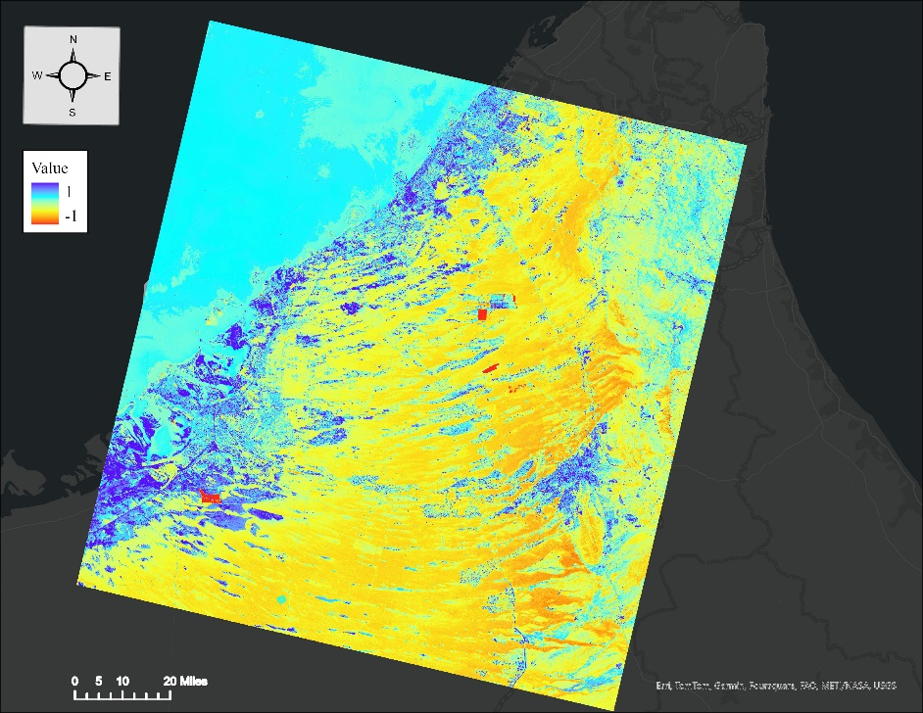

Figure 1) NDWI imagery calculated using NIR and SWIR band values.
Looking at the image, it isn’t clear which pixels indicate high water intensity. The dark blue and light blue values are right beside each other and should ideally represent the same or similar feature but that doesn’t seem to be the case. Whereas in the MNDWI imagery, the assimilation seems to be smoother as shown below.

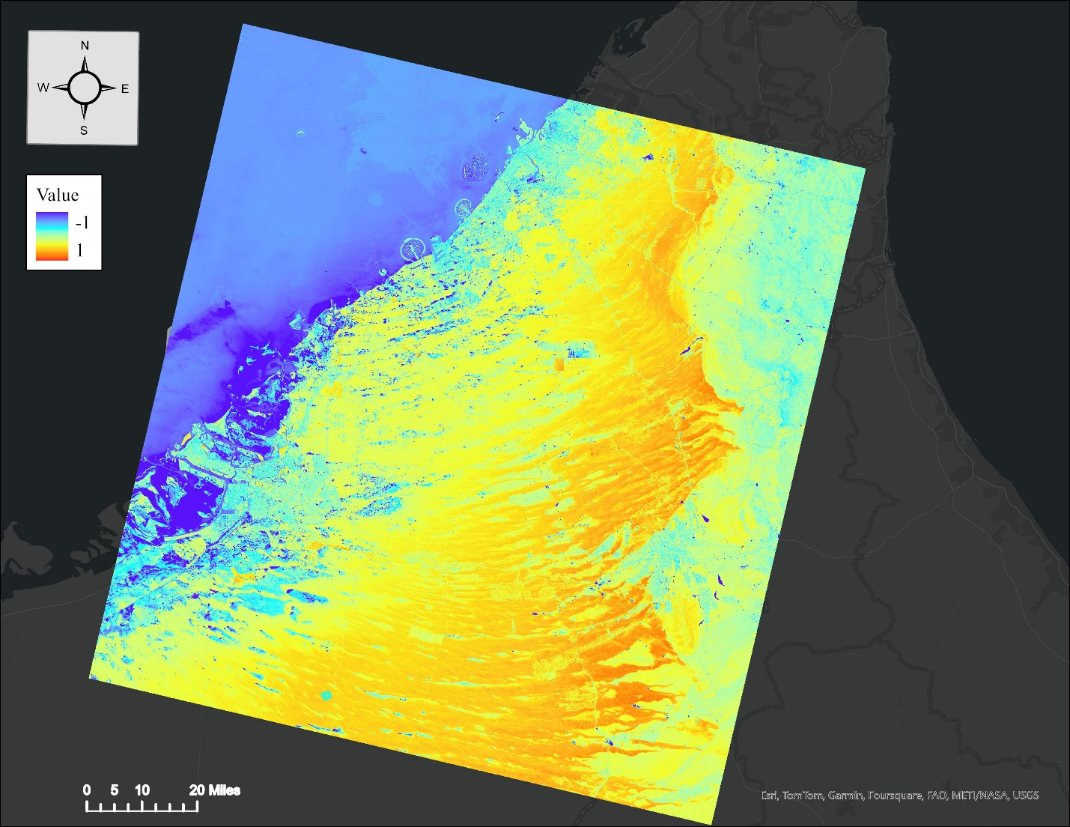

Figure 2) MNDWI imagery calculated using green and SWIR imagery 19th April, 2024.

Process
The Process of calculating MNDWI can be done using ArcGIS Pro using the raster calculator. The formula using Green and SWIR bands would look something like this: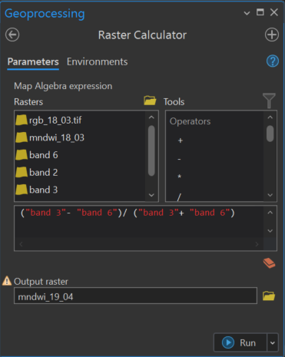
Figure 3) Raster calculator showing MNDWI calculation.
After doing this for both images, The next step would be to reclassify the resulting raster image based on values.
After staring at the pixel values, I decided to make a binary classification, where 0 refers to dry areas (desert, developed) and 1 refers to wet (flooded areas, seas, and ocean). I chose -0.2 as the boundary between these two classes. After zooming in and out of the image, it seemed like this value perfectly represented values right in the middle of being wet and dry.
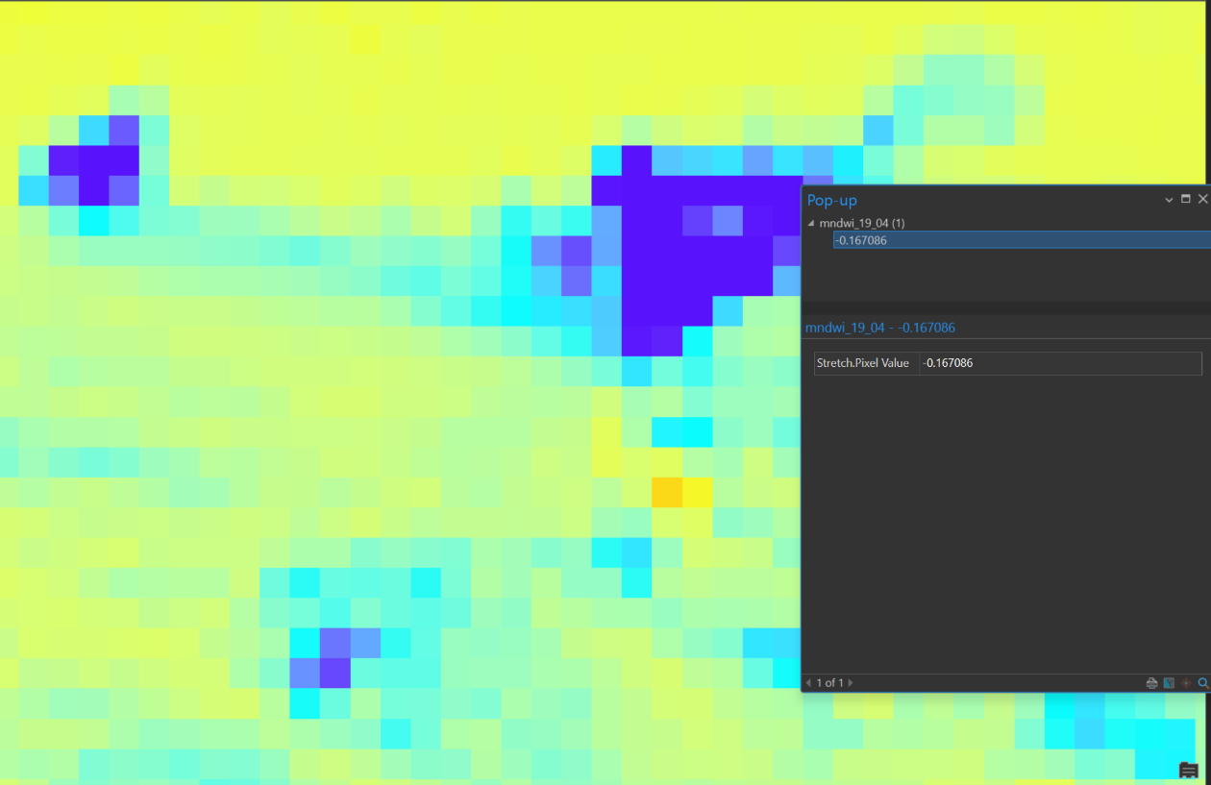
Figure 4) Random Pixel value of -0.167, indicating -0.2 is a good boundary pixel value.
Next step would be to use the raster calculator again to get the reclassified imagery. This step can be done using the Con tool as well.
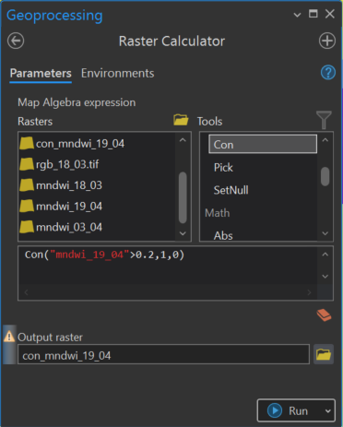
Figure 5) Raster calculator showing the Condition for reclassifcation. If the value is >-0.2, it is mapped to 1, otherwise 0.
The final step would be to use this imagery for both dates and evaluate a change matrix. This can be done by combining the reclassified images into a single raster using the Combine tool. The final imagery should have table columns that represent the classes they represent in the previous images.
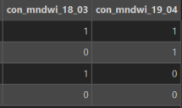
Figure 6) Resulting Combination classes has two columns representing previous and next class combinations from March 18 to April 19, representing change values.

Result and Conclusion
Comparing the two MNDWI images we can see that southern-west regions along the coast of UAE (Sothern Dubai and Abu Dhabi) and the northern-west regions are the most severely affected by the natural disaster.
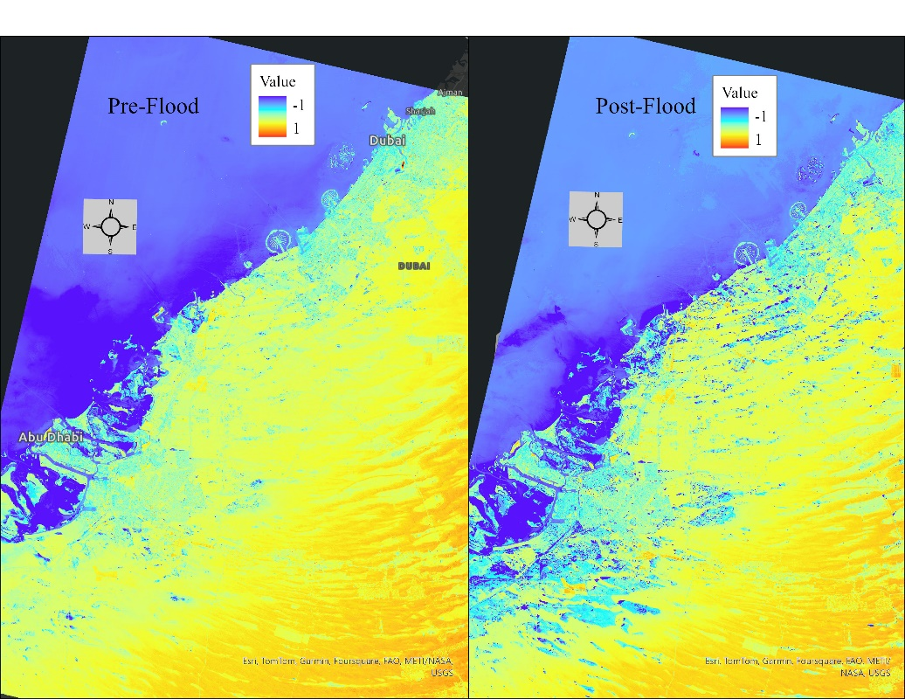

Figure 7) Pre-Flood on the left and Post-Flood on the right MNDVI imageries.
We also see that the spread of water does not follow any pathways or patterns, the topography does not have a meandering effect of water and is spread randomly throughout the surface. This is due to the fact that most of UAE’s geography consists of deserts. Sands in the desert have poor water absorption and containing capacity (Jingyi Huang, 2020).
Populating the values change matrix computed, we see,

Classes | 0(Dry) | 1(Water) | Total
0(Dry) | 17587144 | 10324640 | 27911784
1(Water) | 1951 | 12046404 | 12048355
Total | 17589095 | 22371044 | 39960139

Using this matrix, we can calculate the percentage of pixels that changed from dry to water. This can be done by dividing the value that represents the (0 1) by the total number of pixels and then calculating the percentage.
Percentage of Pixels that changed from dry to wet = (10324640/39960139) * 100
= 25.83735 %
This means approximately 25.84% of the area was covered with water that was previously dry at the peak of the flood.

Areas for Improvement
This classification gives us an idea of the effects caused by the floods in UAE, but it doesn’t give a definitive quantitative analysis of the disaster. This study can be further investigated if the reclassification can be done through a more precise method. The obvious solution to this problem would be to use unsupervised and supervised techniques to classify the raster image into further classes. However, this technique can give undesirable classification. Another way could be to use a machine learning model using Python or R to classify the image based on raster files and class corresponding shapefiles. However, this method requires an awfully large computation time. This step was done initially to try classify the image, but the application stopped responding as the computations increased.

References
Sean Seddon. (18 April 2024) Apocalyptic' Dubai floods shake picture-perfect city https://www.bbc.com/news/world-middle-east-68844405
Albertini, C.; Gioia, A.; Iacobellis, V.; Manfreda, S. Detection of Surface Water and Floods with Multispectral Satellites. Remote Sens. 2022, 14, 6005. https://doi.org/10.3390/rs14236005
Kshetri, Tek. (2018). NDVI, NDBI & NDWI Calculation Using Landsat 7, 8.
F. Khalifeh Soltanian , M. Abbasi , , H. R. Riyahi Bakhtyari. (2019). FLOOD MONITORING USING NDWI AND MNDWI SPECTRAL INDICES: A CASE STUDY OF AGHQALA FLOOD-2019, GOLESTAN PROVINCE, IRAN https://isprs-archives.copernicus.org/articles/XLII-4-W18/605/2019/isprs-archives-XLII-4-W18-605-2019.pdf
Jingyi Huang, Alfred E. Hartemink, Soil and environmental issues in sandy soils,
Earth-Science Reviews ISSN 0012-8252, 2020, https://doi.org/10.1016/j.earscirev.2020.103295.

